# **J2EE vs Java EE vs Jakarta EE**

**1. J2EE (Java 2 Platform, Enterprise Edition)**

**Why it came**

* **Standardization Need**: In the late 1990s, enterprise Java was splintered across proprietary APIs (CORBA, JMS variants, RMI, etc.). J2EE (launched 1999) unified these into a single specification under Sun Microsystems.
* **Component Model**: Introduced Enterprise JavaBeans (EJB) to encapsulate business logic, plus standard APIs for web (Servlets/JSP), messaging (JMS), transactions (JTA), and persistence (JDBC).

**Core Rules & Architecture**

1. **Multi-tier Architecture**
   * **Client tier**: GUIs or web front-ends
   * **Web tier**: Servlets/JSP, HTTP request handling
   * **Business tier**: EJB session and entity beans
   * **Enterprise Information System (EIS) tier**: JDBC data sources, legacy systems via connectors (JCA)
2. **Contract-First Portability**
   * Code written to J2EE contracts (interfaces) must run unmodified on any certified J2EE application server.
3. **Container-Managed Services**
   * **Transactions (JTA)**, **Security**, **Lifecycle** and **Dependency Injection** provided by the EJB/Web container.
4. **Deployment Descriptor-Driven**
   * Early J2EE versions relied heavily on XML descriptors for configuring components, security roles, transaction attributes.

**When & Where to Use**

* **Large, monolithic enterprise apps** requiring robust transactions, clustering, and high availability.
* **Integrations** with legacy systems via standardized connectors.
* **Centralized** on-premise deployments where vendor-certified application servers guarantee service levels.

**Real-World Examples**

1. **Banking Core System (circa 2002)**
   * **EJB-based** transaction processing for account management, running on BEA WebLogic Server.
   * JMS queues for asynchronous payment clearing between branches.
2. **Telecom Billing Platform**
   * Servlets handling customer web portals; session beans for rating calls; MDBs consuming CDR (Call Detail Record) messages via JMS.

**2. Java EE (Java Platform, Enterprise Edition)**

*(J2EE was rebranded to Java EE with version 5 in 2006 to emphasize simplification and modern language features.)*

**Why it evolved**

* **Reduce Boilerplate**: Developers complained of EJB complexity and verbose XML.
* **Embrace Annotations & POJOs**: Java EE 5 introduced EJB 3.0 with annotations, CDI (Contexts & Dependency Injection), and JPA for ORM, making components lightweight and configuration-by-exception.

**Core Rules & Architecture Enhancements**

1. **Convention over Configuration**
   * Default settings via annotations (e.g., @Stateless, @WebServlet), drastically reducing XML.
2. **POJO-First EJB**
   * Plain Java classes as beans; containers manage services by annotation.
3. **Profiles**
   * **Web Profile**: A lightweight subset (Servlets, JSP, JPA, CDI) for web apps without full EJB stack.
4. **Modular Packaging**
   * Standard .war, .ear modules with clear layering.

**When & Where to Use**

* **Modern enterprise applications** needing a balance of power and developer productivity.
* **Microservices-style** web apps leveraging the Web Profile.
* **Cloud-enabled** apps on platforms like Payara Cloud or Oracle Cloud.

**Real-World Examples**

1. **E-commerce Platform**
   * RESTful services with JAX-RS, CDI-managed business services, JPA to MySQL, deployed as WAR on GlassFish.
2. **Government Case Management**
   * Full Java EE 7 stack: JMS for eventing, JSF for UI, EJB 3.2 for business rules, integrating legacy databases with JCA.

**3. Jakarta EE**

*(In 2017, Oracle transferred Java EE to the Eclipse Foundation; renaming to Jakarta EE began with version 8.)*

**Why it evolved**

* **Open Governance**: Move from Oracle-driven stewardship to a vendor-neutral, community-led Eclipse Foundation project.
* **Cloud-Native Evolution**: Emphasis on modularity, microservices, and faster innovation cycles.

**Core Rules & Architecture Innovations**

1. **Jakarta Namespace**
   * Package rename from javax.* to jakarta.* to allow independent evolution.
2. **Decoupled Specifications**
   * Individual APIs evolve on separate schedules (e.g., Jakarta REST, Jakarta MVC).
3. **Profiles & Cloud Native**
   * **Full Profile**, **Web Profile**, and emerging specialized profiles (e.g., MicroProfile integration).
4. **Community-Driven Releases**
   * Faster release cadence (annual) and open specification ballots.

**When & Where to Use**

* **Cloud-native microservices** needing container friendliness and rapid updates.
* **Enterprises adopting Kubernetes** and modern DevOps pipelines.
* **Organizations** seeking a vibrant ecosystem without vendor lock-in.

**Real-World Examples**

1. **Logistics Microservices**
   * Jakarta RESTful services deployed in Kubernetes pods, using CDI for config, Jakarta Persistence to PostgreSQL, scaled via Helm charts.
2. **Healthcare Information Exchange**
   * Event-driven architecture with Jakarta Messaging on Apache ActiveMQ, adapters built with Jakarta Connectors, packaged as modular OSGi-ready JARs.

**Summary of Evolution**

| **Attribute** | **J2EE** | **Java EE** | **Jakarta EE** |
| --- | --- | --- | --- |
| Governance | Sun Microsystems | Sun → Oracle | Eclipse Foundation (community) |
| First Release | 1999 | 2006 (Java EE 5) | 2019 (Jakarta EE 8) |
| Configuration Style | XML descriptors | Annotations + XML | Annotations + Jakarta namespace |
| Component Model | EJB 2.x beans | EJB 3.x POJOs, CDI | Jakarta Beans, CDI evolves |
| Ideal Use Cases | Monolithic, on-premise apps | Web apps, modern monoliths & early microservices | Cloud-native microservices & modular enterprise apps |

## 1. Introduction to “Spring”

**What it is:**  
Spring is a lightweight, open-source Java platform that provides a comprehensive programming and configuration model for modern Java-based enterprise applications. At its heart is a **dependency injection** (DI) container—also called an **Inversion of Control** (IoC) container—that manages your application’s objects (“beans”), wiring them together according to configuration rather than hard-coded new statements.

**Why it came about:**

* **EJB complexity**: Early J2EE (now Jakarta EE) used heavyweight EJBs (Enterprise JavaBeans) with verbose XML and clunky container requirements.
* **Testability & decoupling**: Developers wanted POJO-based (plain old Java object) components, easier unit testing, and loose coupling.
* **Modularity**: A modular approach to add only the pieces you need, rather than an all-or-nothing container.

**Core “rules” / guiding principles:**

1. **Prefer DI over new** — let the container assemble your beans.
2. **POJO-first** — your classes don’t need to implement special interfaces.
3. **Convention over Configuration** — sensible defaults minimize XML or annotation clutter.
4. **Layered architecture** — separate web, service, and data-access concerns into distinct packages/modules.
5. **Use AOP for cross-cutting concerns** — logging, transactions, security via “aspect” modules rather than scattering code.

**Where & when to use Spring itself:**

* Any Java enterprise or web application needing loose coupling and testability.
* When you want to avoid heavyweight application servers/EJB containers.
* If you plan to mix and match technologies (JPA, JMS, MVC) under one umbrella.

**Real-world examples of “pure” Spring usage**

1. **E-commerce Order Processing**
   * Beans: OrderService, PaymentService, InventoryService
   * Configuration: XML or Java-config wiring service dependencies
   * Benefits: easily swap out PaymentService implementation (e.g. Stripe vs. PayPal)
2. **Content Management System (CMS)**
   * Uses Spring MVC for controller/view layer, Spring Data for repository layer
   * IoC manages controllers, services, and DAOs
   * AOP module for audit logging on every content change
3. **Customer Relationship Management (CRM)**
   * Loosely couples modules for Contacts, Leads, Analytics
   * Profiles (@Profile) to load different bean sets for dev vs. prod
   * Unit tests instantiate only needed beans via standalone Spring context

## 2. Spring Framework

**What it is:**  
The **Spring Framework** is the full modular ecosystem built around the core IoC container. Key modules include:

* **Spring Core & Beans** (DI/IoC)
* **Spring AOP** (aspect-oriented programming)
* **Spring Data** (JPA, MongoDB, Redis, etc.)
* **Spring MVC** (web-framework)
* **Spring Security** (authentication/authorization)
* **Spring Batch**, **Spring Integration**, **Spring Cloud**, etc.

**Why it came about:**

* To provide a unified, consistent programming model across web, data, security, batch, messaging, and cloud.
* To tackle cross-cutting concerns (transaction, security, logging) in a decoupled way.
* To allow incremental adoption: pick only MVC, or only Data, etc.

**Core “rules” / best practices:**

1. **Layering:**
   * @Controller in web layer
   * @Service in business logic
   * @Repository in data-access
2. **Transactional boundaries:**
   * Annotate service methods with @Transactional to manage commits/rollbacks
3. **Exception translation:**
   * @Repository beans translate checked persistence exceptions into Spring’s DataAccessException hierarchy
4. **Use Spring’s stereotypes and annotations** rather than manual bean definition
5. **Externalize configuration:**
   * application.properties / application.yml or environment variables

**Where & when to use Spring Framework:**

* Building **monolithic** web applications with MVC, data access, security, etc.
* When you need fine-grained control over each layer and integration points.
* In large enterprises that require features from multiple Spring modules.

**Real-world examples of full Spring Framework applications**

1. **Netflix OSS Integration**
   * Uses **Spring Cloud** (built on Spring Framework) for service discovery (Eureka), load balancing (Ribbon), and circuit breaking (Hystrix).
   * Core services annotated with @Component, @RestController, and leverage Spring Security for OAuth2.
2. **Banking Payroll System**
   * Spring Batch for scheduled payroll processing jobs
   * Spring Data JPA for account and transaction repositories
   * Spring Security for multi-factor authentication and role-based access control
3. **Inventory Management**
   * Spring Integration to connect ERP message queues (JMS) with warehouse DB updates
   * Spring AOP to log inventory adjustments and enforce rate limits
   * Spring MVC to expose web dashboards for stock levels

## 3. Spring Boot

**What it is:**  
Spring Boot is an **opinionated** layer on top of the Spring Framework that **auto-configures** based on classpath contents, provides **“starter”** dependencies to pull in only what you need, and lets you **embed** a web server (Tomcat, Jetty, Undertow) so you can deliver a single runnable JAR.

**Why it came about:**

* Even with Spring’s Java-based config, **boilerplate** was high: XML imports, manual component scans, explicit server setup.
* Developers wanted **“just-run”** apps with minimal configuration.
* The rise of microservices emphasized small, standalone, self-contained apps.

**Core “rules” / conventions:**

1. **Use “starters”:** e.g. spring-boot-starter-web, starter-data-jpa, starter-security
2. **Rely on auto-configuration:** override only if you need custom behavior (via properties or explicit @Configuration classes)
3. **Embed your server:** no need to deploy WARs to an external Tomcat
4. **Externalize all settings:** application.properties or application.yml with profiles (application-dev.yml, application-prod.yml)
5. **Actuator for health and metrics:** include spring-boot-starter-actuator for production-ready insights

**Where & when to use Spring Boot:**

* **Microservices** and cloud-native apps needing rapid spin-up and independent deployment.
* **Prototype/demo** projects where you want “Hello, world” in seconds.
* **Standalone** CLI tools or batch jobs packaged as executable JARs.

**Real-world examples of Spring Boot applications**

1. **Fintech Transaction Microservice**
   * spring-boot-starter-web + starter-data-mongodb
   * Runs in Docker, auto-scales on Kubernetes
   * Uses Actuator endpoints (/actuator/health, /metrics) for readiness/liveness probes
2. **Ride-Sharing REST API**
   * starter-webflux for reactive REST endpoints
   * starter-security with JWT authentication
   * Configuration profiles to switch between mock and production GPS providers
3. **Monitoring & Alerts Service**
   * starter-actuator + starter-amqp to consume Prometheus alerts via RabbitMQ
   * Exposes custom health checks and metrics via /actuator/prometheus
   * Packaged as a single JAR; no external servlet container needed

**Summary Comparison**

| **Aspect** | **Spring (Core)** | **Spring Framework (Full)** | **Spring Boot** |
| --- | --- | --- | --- |
| **Primary Concern** | IoC / DI container | Modular ecosystem (MVC, Data, Security, etc.) | Auto-configuration & starters |
| **Config Style** | XML / Java-Config / Annotations | Annotations + Java-Config | “Zero-config” + application.yml |
| **Deployment** | Requires container setup | Ditto | Embedded server; runnable JAR/WAR |
| **Use Cases** | Any decoupled Java app | Monolithic enterprise apps | Microservices, prototypes, CLI tools |
| **Learning Curve** | Gentle—focus on DI | Moderate—learn each module | Very quick—opinionated defaults |

## Loose Coupling vs. Tight Coupling

**Definitions & Origins**

* **Coupling** describes how interdependent two software modules are.
* **Tightly coupled** modules know too much about each other’s internals (classes instantiate each other directly, share global state). This was common in early procedural code and monolithic Java apps—fast to write but hard to change.
* **Loosely coupled** modules interact through well-defined abstractions (interfaces, events, dependency injection). This emerged alongside component-based architectures, test-driven development, and the need for systems that evolve rapidly without ripple-effect changes.

**Why It Matters**

* **Maintainability**: Loose coupling localizes changes; tight coupling causes wide-ranging regressions.
* **Testability**: Mocking/stubbing is easy with interfaces; impossible when code new’s up concrete classes.
* **Reusability & Flexibility**: Loosely coupled components can be swapped or repurposed; tightly coupled ones cannot.

**Rules & Best Practices**

1. **Depend on abstractions, not concretions**
   * Code to interfaces (PaymentProcessor), not implementations (StripeProcessor).
2. **Use Dependency Injection (DI)**
   * Let a container or factory inject collaborators rather than new-ing them.
3. **Favor Composition over Inheritance**
   * Compose behaviors at runtime instead of building deep type hierarchies.
4. **Encapsulate what varies**
   * Define stable boundaries; keep volatile details behind interfaces or adapters.
5. **Apply Interface Segregation**
   * Break large interfaces into smaller, role-specific ones so clients only depend on what they use.

**When & Where to Use**

* **Large, evolving codebases** (enterprise apps, microservices): always aim for loose coupling.
* **Plugin architectures** (e.g. IDE extensions, e-commerce payment plugins): loose coupling enables hot-swapping.
* **Teams working in parallel** on different modules: clear interfaces reduce merge conflicts.
* **Tight coupling may be acceptable** in small, throwaway scripts or prototypes where speed of delivery trumps maintainability.

**Real-World Examples**

| **Coupling Type** | **Example Scenario** | **Why It’s That Coupling** |
| --- | --- | --- |
| **Loose** | **Payment Gateway Integration**<br/>Define a PaymentProcessor interface with implementations for Stripe, PayPal, etc., wired via Spring DI. Swap or extend processors without touching business code. | Uses **abstractions**, **DI**, and **interface segregation**. |
| **Loose** | **Event-Driven Microservices**<br/>Services publish/subscribe to a message broker (Kafka/RabbitMQ). Producers don’t know consumers’ identities or numbers. | Decouples modules via **asynchronous messaging**. |
| **Loose** | **Plugin-Based CMS**<br/>Core CMS defines extension points; plugins implement them and are discovered via classpath scanning. | Core relies on **contracts**, plugins on **service loader** pattern. |
| **Tight** | **Legacy Monolith**<br/>Service classes directly new DAO classes and call JDBC; changing DB schema forces edits across many classes. | Direct instantiation and shared global state. |
| **Tight** | **Utility Class Overuse**<br/>Calling static helper methods (Utils.doX()) everywhere; difficult to mock or override behavior. | Global static methods create hidden dependencies. |
| **Tight** | **Deep Inheritance Chains**<br/>Business logic buried in subclasses; a change at the top of the hierarchy affects all children unpredictably. | Inheritance entwines implementations. |

**JavaBean, POJO, and Spring Bean**

| **Aspect** | **POJO** | **JavaBean** | **Spring Bean** |
| --- | --- | --- | --- |
| **Definition** | Plain Old Java Object: any class without special restrictions. | A Java class following specific conventions (see below). | Any POJO managed by the Spring IoC container. |
| **Why It Came** | To free code from heavyweight entity/EJB requirements. | To support visual builders & frameworks via introspection. | To standardize object creation, wiring, and lifecycle. |
| **Key Rules** | – No required interfaces<br/>– No enforced annotations or base classes | 1. Public no-arg constructor<br/>2. Private fields<br/>3. Public getters/setters (“properties”)<br/>4. Serializable (optional but common)<br/>5. Follows naming conventions<br/> | 1. Defined in Spring config (XML, Java-Config, or via @Component / @Bean)<br/>2. POJO with optional lifecycle callbacks (@PostConstruct, @PreDestroy)<br/>3. Scoped (singleton, prototype, etc.) |
| **Use Cases** | Any simple domain or utility object | UI components, JSP/JSF backing beans, data carriers for frameworks | Service/repository components, data sources, controllers in Spring apps |

**1. POJO (Plain Old Java Object)**

* **Why**: Emerged to simplify Java code—no heavy interfaces or container contracts.
* **Rules**: None beyond standard Java syntax; you’re free to design as you see fit.
* **When to Use**: Everywhere—entities, DTOs, utility classes.
* **Real-World Examples**
  1. **User Entity** in a JPA layer: simple getters/setters, no EJB interfaces.
  2. **Address Value Object** passed between services.
  3. **CsvParserConfig** holding delimiter and quoting rules for a CSV utility.

**2. JavaBean**

* **Why**: Introduced in the late 1990s to let GUI builders and frameworks inspect and manipulate Java components via reflection.
* **Rules**:
  1. **No-arg constructor** so tools can instantiate.
  2. **Private fields** accessed via standard getters/setters (getX(), setX()).
  3. **Serializable** for possible persistence or remoting.
* **When to Use**: In any framework relying on bean introspection—JSP tag libraries, JSF, some older ORM mappers.
* **Real-World Examples**
  1. **JSF Backing Bean**:

public class LoginBean implements Serializable {

private String username;

private String password;

public LoginBean() { }

public String getUsername() { … }

public void setUsername(String u) { … }

// …

}

* 1. **JSP Form Bean**: carries form fields between JSP pages and servlets.
  2. **JavaBeans Activation Framework (JAF)** DataSource bean for email attachments.

**3. Spring Bean**

* **Why**: To have Spring manage object lifecycles, wiring, configuration, and cross-cutting concerns (transactions, security).
* **Rules**:
  1. **Register** your POJO in Spring (via <bean> in XML, @Bean in @Configuration, or @Component scan).
  2. **Declare scope** (singleton by default, or prototype, request, session, etc.).
  3. **Optionally** implement lifecycle callbacks or use @PostConstruct / @PreDestroy.
* **When to Use**: In any Spring-powered application—monolith, microservice, batch job, or integration platform.
* **Real-World Examples**
  1. **DataSource Bean**:

@Bean

public DataSource dataSource() {

HikariDataSource ds = new HikariDataSource();

ds.setJdbcUrl(...);

return ds;

}

* 1. **@Service Business Bean**:

@Service

public class OrderService {

@Autowired PaymentProcessor processor;

// …

}

* 1. **@Repository DAO Bean** for a JPA repository:

@Repository

public interface UserRepository extends JpaRepository<User, Long> { }

By understanding **coupling** and the distinctions among **POJO**, **JavaBean**, and **Spring Bean**, you’ll be better equipped to design flexible, maintainable Java applications and select the right abstraction level and component style for each layer of your architecture.

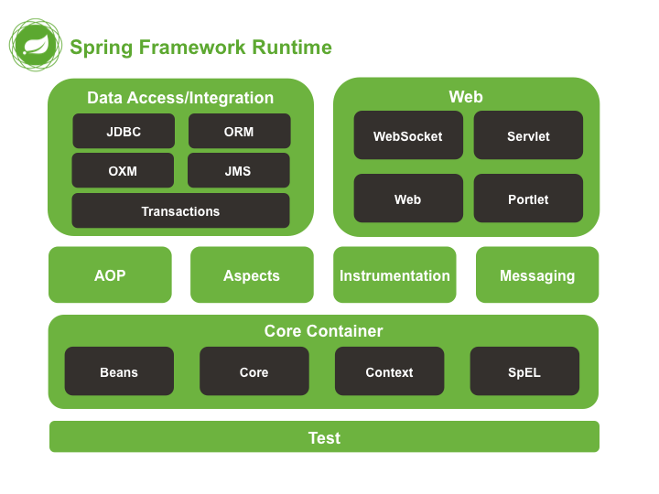

**Architecture of Spring Framework**

Before jumping to the architecture of spring, we should know the following term:

**1. DI**

It is difficult to comprehend what is Spring Framework without understanding what Dependency Injection and Inversion of Control is. Likewise, Dependency Injection is one of the kinds of Inversion of Control (IoC).

**2. IOC (Inversion of Control)**

This is the standard of object-oriented programming, wherein objects of the program don’t rely upon solid executions of different objects; however, they may know about their abstractions (interfaces) for the later association**.**

**3. Dependency Injection**

It is a piece of basic structure designs, in which for each capacity of the application, there is one, a restrictively autonomous item (administration) that can want to utilize different articles (conditions) known to it by interfaces. Conditions are moved (actualized) to the administration at the hour of its creation. This is where we present a component of one class into another. Practically speaking, DI is actualized by passing parameters to the constructor or utilizing setters. Libraries that execute this methodology are additionally called IoC containers.

**4. AOP**

It is a piece of basic structure designs, in which for each capacity of the application, there is one, a restrictively autonomous item (administration) that can want to utilize different other objects (dependencies) known to it by interfaces. Dependencies are moved (implemented) to the administration at the hour of its creation. This is where we present a component of one class into another.

**5. Architecture Module**

* **The Core Module:** Provides the Dependency Injection (DI) include the Spring system’s fundamental idea. This module contains the Bean Factory, an execution of Factory Pattern, which makes the bean according to the designer’s setups in an XML record.
* **AOP Module:** The Aspect-Oriented Programming module enables engineers to characterize technique interceptors and point slices to keep the worries separated. It is arranged at run time, so the accumulation step is skipped. It focuses on the explanatory exchange of the executives, which is simpler to keep up.
* **DAO Module:** This gives a reflection layer to the low-level assignment of making an association, discharging it and so forth. It additionally keeps up a chain of command of important exemptions instead of tossing confounded blunder codes from explicit database sellers. It utilizes AOP to oversee exchanges. Exchanges can likewise be overseen automatically.
* **ORM Module:** Spring doesn’t give its own ORM execution however offers mixes with mainstream Object-Relational mapping devices like Hibernate, iBATIS SQL Maps, Oracle TopLink and JPA and so on.
* **Web Module:** Spring accompanies MVC structure which facilitates the undertaking of creating web applications. It likewise incorporates well with the most mainstream MVC structures like Struts, Tapestry, JSF.

**Spring Core Container**

Core Container has the following aspects:

* **Core**
* **Beans**
* **Context**
* **AOP**
* **SpEl**
* **Expression Language modules (Aspects)**

The Core and Beans modules give the structure’s essential bits, including the IoC and Dependency Injection features. The Bean Factory is a propelled use of the creation line structure. It clears the necessity for programmed singletons and empowers you to decouple the structure and of conditions from your genuine program method of reasoning. The Context module develops the Core and Beans modules’ solid base: it is an approach to get to objects in a structure style way that resembles a JNDI library.

The Application Context interface is the purpose of the intermingling of the Context module. The Expression Language module gives a stunning verbalization language to addressing and controlling an article outline at runtime. It is a development of the bound-together explanation language (united EL) as decided in the JSP 2.1 assurance.

The language supports setting and getting property estimations, property task, method call, getting to the setting of bunches, varieties and indexers, reasonable and number shuffling managers, named variables, and recuperation of things by name from Spring’s IoC compartment.

**Information(Data) Access/Combination(Integration)**

Identity and Access Management (IAM) is a vital component of data security for any enterprise, serving as a centralized portal. Some of the components are discussed in the following:

* **JDBC:** It provides a JDBC-reflection layer that clears the need to do monotonous JDBC coding and parsing of database-trader unequivocal bungle codes.
* **ORM:** It provides a blend layer to standard item communal plot APIs that contain JPA, JDO, Hibernate, and iBatis. Using the ORM group, you can use these O/R-mapping frameworks in the mix with the whole of various features Spring offers, for instance, the clear, authoritative trade the board incorporates referenced as of now.
* **OXM:** It provides a casting layer that supports Object and XML plotting utilization for JAXB, Castor, XMLBeans, JiBX, and XStream.
* **JMS:** It provides features for conveying and consuming messages.

**Web**

The web has the following layers:

* **Web**
* **Web-MVC**
* **Web-Socket**
* **Web-Portlet**

**Spring Web:** It gives fundamental web-arranged fuse features; for instance, multipart archive moves convenience and the presentation of the IoC holder using servlet crowd individuals and a web-organized application setting.

**Web** **Servlet:** It has Spring’s MVC execution for web applications.

**Web Socket:** Module contains the assistance classes for organizing a model Struts web level inside a Spring application.

**Conclusion – Spring Architecture**

In this article, we have presented with Spring Architecture, its engineering and fundamental highlights. We have figured out how the Spring structure causes us to grow loosely coupled applications utilizing dependency injection where the dependent objects are infused using a configuration file. The Spring system is a direct basic, lightweight, and strong structure to assemble present-day Java-based applications to put it plainly.

**1. Container Bootstrap & Bean Definition Loading**

1. **Configuration Parsing**
   * On startup, Spring reads your configuration sources:
     + **Java-config classes** (@Configuration + @Bean)
     + **Component scanning** (@ComponentScan)
     + **XML files** (if any)
   * Each @Bean method or <bean> element yields a **BeanDefinition**: a metadata object describing bean class, scope, constructor args, property values, init/destroy methods, etc.
2. **BeanFactoryPostProcessor Phase**
   * Before any beans are instantiated, Spring invokes all registered **BeanFactoryPostProcessors** (e.g. PropertySourcesPlaceholderConfigurer, ConfigurationClassPostProcessor).
   * These can tweak BeanDefinitions (e.g. replace ${…} placeholders, register additional beans for @Import).
3. **ApplicationContext Ready**
   * At this point the ApplicationContext (typically AnnotationConfigApplicationContext or in a web app AnnotationConfigWebApplicationContext) is fully loaded with all BeanDefinitions registered, but no singleton bean instances yet.

**2. Bean Instantiation & Dependency Injection**

1. **Instantiate Singletons**
   * By default, all singleton-scoped beans are created eagerly.
   * For each BeanDefinition:
     1. **Instantiation** via no-arg or constructor with arguments (Spring resolves references to other beans here).
     2. **Populate Properties** (setter injection or field injection).
     3. **Aware Callbacks** (e.g. BeanNameAware, ApplicationContextAware).
     4. **BeanPostProcessor.beforeInitialization** — hooks run before any @PostConstruct or afterPropertiesSet().
     5. **Initialization** (@PostConstruct, InitializingBean.afterPropertiesSet(), or custom init-method).
     6. **BeanPostProcessor.afterInitialization** — e.g. wrapping with a proxy for AOP.
2. **Lazy & Prototype Beans**
   * Beans marked lazy=true are skipped until first requested.
   * prototype beans are created on demand rather than at startup; their lifecycle stops after initialization (Spring doesn’t manage destruction).

**3. AOP Proxy Creation**

* **When a bean’s class or methods are matched by an Advisor (pointcut + advice)**, Spring’s ProxyFactoryBean (or auto-proxying BeanPostProcessor) wraps the raw instance in a proxy.
  + **JDK Dynamic Proxy** if the bean implements at least one interface.
  + **CGLIB Proxy** otherwise (subclassing the target class).
* **Real-World Example #1: Transaction Management**
  + A @Service OrderService has methods annotated @Transactional.
  + At after-init, Spring creates a proxy that intercepts calls to placeOrder(), starts a transaction, invokes the real method, then commits/rolls back.
  + Your business code simply calls orderService.placeOrder(), unaware of the proxy magic.

**4. Application Events & Listeners**

1. **Publishing Events**
   * Any bean that implements ApplicationEventPublisherAware can publishEvent(...) an ApplicationEvent (or any object in Spring 4.2+).
2. **Listener Invocation**
   * Beans annotated @EventListener or implementing ApplicationListener<YourEvent> receive events asynchronously (by default in the caller thread, but you can configure an async ApplicationEventMulticaster).

* **Real-World Example #2: User Registration Workflow**
  + UserService publishes a UserRegisteredEvent after saving a user.
  + A separate @Component EmailNotificationListener listens for UserRegisteredEvent and sends a welcome email.
  + Another @Component AnalyticsListener tracks sign-up metrics—both concerns decoupled from the core registration flow.

**5. Runtime Resource Management & Scheduling**

* **Resource Loading**
  + Spring’s ResourceLoader abstracts file-system, classpath, URL resources. Beans can @Value("${logo.path}") Resource logo; and at runtime Spring resolves and injects the actual file.
* **Task Scheduling & Execution**
  + Beans annotated @Scheduled are discovered by the ScheduledAnnotationBeanPostProcessor and registered with a TaskScheduler.
  + @Async methods are wrapped so calls happen on threads from a configurable TaskExecutor.
* **Real-World Example #3: Periodic Data Sync**
  + A @Service CacheRefresher bean with

@Scheduled(fixedDelayString = "${cache.refresh.ms}")

public void refresh() { … }

* + On startup, Spring’s scheduler registers this method; every cache.refresh.ms milliseconds it’s invoked on a worker thread, keeping a local cache in sync with a remote API.

**6. Context Shutdown & Bean Destruction**

1. **Shutdown Hook**
   * ApplicationContext registers a JVM shutdown hook, ensuring graceful shutdown on SIGTERM.
2. **Disposable Callbacks**
   * For each singleton bean:
     1. Call any @PreDestroy methods or DisposableBean.destroy().
     2. Release resources (threads pools, DB connections).
3. **Publish ContextClosedEvent**
   * Any @EventListener for ContextClosedEvent can perform cleanup logic.

**Putting It All Together: A Web App Workflow**

1. **Startup**
   * ContextLoaderListener creates a root ApplicationContext.
   * DispatcherServlet creates a child WebApplicationContext for MVC controllers.
2. **Handling a Request**
   * HTTP request → DispatcherServlet → HandlerMapping picks a @Controller bean.
   * Controller method invoked on a proxy (if AOP advices apply).
   * Services/DAOs injected into controller are ready to go.
   * After controller returns, views are resolved, rendered, and response sent.
3. **Background Jobs & Events**
   * Meanwhile, @Scheduled tasks and @Async methods run on background threads.
   * Custom events flow between modules without tight dependencies.
4. **Shutdown**
   * On application stop, Spring cleans up resources, invokes destroy callbacks, and notifies listeners.

**Why This Matters**

* **Consistency**: Every bean follows the same lifecycle hooks—easy to reason about initialization and cleanup.
* **Extensibility**: Post-processors let you inject functionality (AOP, configuration overrides) without touching your code.
* **Decoupling**: Events, DI, and proxies keep modules focused on business logic, with infrastructure concerns applied declaratively.
* **Resilience**: Graceful shutdown and resource management minimize leaks and ensure a clean environment on restart.

By understanding the **runtime phases**—from bean definition loading through instantiation, proxying, event dispatch, and shutdown—you can design Spring applications that are robust, maintainable, and modular in real-world production environments.

## What Are Spring Modules?

Spring isn’t a single monolithic JAR but a **collection of modular libraries**, each focused on a distinct area of enterprise application development. You “pick and choose” just the pieces you need (IoC, AOP, data access, web, batch, security, cloud, etc.), without dragging in unnecessary transitive dependencies.

**Why Spring Modules Were Introduced**

1. **Incremental Adoption**
   * Teams could adopt just the Core container for DI, then later pull in MVC, then Data, etc.
2. **Looser Coupling**
   * Applications depend only on the modules they actually use, limiting API surface and version-conflict risk.
3. **Maintainable Releases**
   * Each module can ship updates on its own cadence (security, bugfixes, feature enhancements).

**Core “Rules” Around Spring Modules**

1. **POJO-First**
   * Every module builds on plain Java objects—no need to implement heavy APIs.
2. **Annotation & Java-Config Over XML**
   * While XML wiring still works, the modern “rule” is: use @Configuration + @ComponentScan + module-specific stereotypes.
3. **Layered Architecture**
   * Only wire together modules in the layer you’re working (e.g. Data modules only in the repository layer).
4. **Auto-Configuration Opt-In**
   * With Spring Boot, auto-configurations are enabled per module via “starter” dependencies; override only when you need custom behavior.
5. **Minimal Classpath**
   * Don’t pull in Web modules for a pure batch job; don’t include JDBC if you’re only using a NoSQL store.

**When & Where to Use Spring Modules**

| **Module Category** | **Use Case** |
| --- | --- |
| **Core Container** | Any Java app needing DI/IoC (foundation). |
| **Data Access & Integration** | JDBC, JPA, MongoDB, Redis, JMS, transaction mgmt. |
| **Web & Remote** | MVC, WebFlux, WebSocket, REST, RMI, Web Services. |
| **AOP & Instrumentation** | Cross-cutting concerns: logging, transactions. |
| **Batch & Scheduling** | Long-running jobs, ETL pipelines. |
| **Security** | Authentication, authorization, method-level ACL. |
| **Cloud & Microservices** | Service discovery, config, circuit breakers. |
| **Testing** | Unit, integration, mock support for all the above. |

Use a module whenever your application needs that specific capability—no more, no less.

**Key Spring Modules (Overview)**

1. **Spring Core & Beans**
   * The IoC container, BeanFactory / ApplicationContext, @Component / @Bean, lifecycle callbacks.
2. **Spring Context**
   * Adds internationalization (i18n), resource loading, event publication.
3. **Spring AOP**
   * Aspect-oriented programming: @Aspect, pointcuts, advice for cross-cutting logic.
4. **Spring Data**
   * Repositories for JPA, MongoDB, Redis, Neo4j, Cassandra; CrudRepository, query derivation.
5. **Spring JDBC & Transaction**
   * JdbcTemplate, PlatformTransactionManager, declarative @Transactional.
6. **Spring MVC & WebFlux**
   * Dispatcher servlet, controllers, view resolvers (Thymeleaf, JSP), reactive WebFlux stack.
7. **Spring Security**
   * Filters, method security (@PreAuthorize), OAuth2 / JWT support.
8. **Spring Batch**
   * Chunk-oriented processing, job/step configuration, restartability.
9. **Spring Integration & AMQP**
   * Message channels, routers, adapters (JMS, Kafka, RabbitMQ).
10. **Spring Cloud**
    * Netflix OSS integration (Eureka, Ribbon, Hystrix), config server, Kubernetes, Sleuth/Zipkin.
11. **Spring Test**
    * @SpringBootTest, MockMvc, @DataJpaTest, context caching, test slices.

**Real-World Examples**

**1. E-Commerce Platform**

* **Modules Used**: Core, Beans, Data JPA, JDBC, MVC, Security, Integration (RabbitMQ), Cloud Config
* **Why**:
  + **Core/Beans** for wiring services (OrderService, PaymentService).
  + **Data JPA** with JpaRepository<User,Long> for customers.
  + **JDBC** + @Transactional for sharded reporting tables.
  + **MVC** for storefront controllers and Thymeleaf views.
  + **Security** to enforce role-based access (ADMIN vs. CUSTOMER).
  + **Integration** to publish “order placed” events to RabbitMQ.
  + **Cloud** for centralized configuration across dev/test/prod.

**2. Financial Batch Processing**

* **Modules Used**: Core, Batch, JDBC, Transaction, AOP, Test
* **Why**:
  + **Batch** to define jobs that process end-of-day settlements in chunks of 10,000 records.
  + **JDBC+Transaction** for atomic writes to the ledger tables.
  + **AOP** to apply retry and back-off around transient DB errors.
  + **Test** with @SpringBatchTest and in-memory H2 for rapid CI feedback.

**3. Cloud-Native Microservices Ecosystem**

* **Modules Used**: Boot Starters (WebFlux, Data MongoDB), Security (OAuth2), Cloud Netflix (Eureka, Ribbon), Sleuth/Zipkin
* **Why**:
  + **WebFlux** for non-blocking user service.
  + **Data MongoDB** for schema-less storage of user profiles.
  + **Security OAuth2** for token-based auth across services.
  + **Eureka** for service discovery and Ribbon for client-side load balancing.
  + **Sleuth/Zipkin** to trace requests end-to-end.

**Bringing It All Together**

By composing only the modules you need—adhering to the core rules of POJO-first design, minimal classpath, and layered separation—you gain:

* **Fine-grained control** over dependencies and versioning
* **Lightweight deployments**, avoiding “kitchen sink” frameworks
* **Easier testing**, since each slice can be spun up with just its required modules
* **Incremental evolution**, as new capabilities arrive in their own modules without touching your existing code

Use the Spring modules model to tailor your architecture: wire in only what your service actually needs, keep your JARs lean, and let each module do one thing well.

## 1. Spring IoC (Inversion of Control)

**What & Why it Came**

* **Definition:** IoC is a design principle where control of object creation and wiring is inverted—rather than your code newing its collaborators, an external container does it for you.
* **Origins:** Early J2EE/EJB apps were heavyweight and tightly coupled; developers wanted:
  1. **Looser coupling** between components
  2. **Easier testing** of individual classes
  3. **Simpler configuration** than verbose XML or container contracts

Spring introduced its IoC container in 2003 to let you build POJO-based apps where dependencies are injected rather than constructed inline.

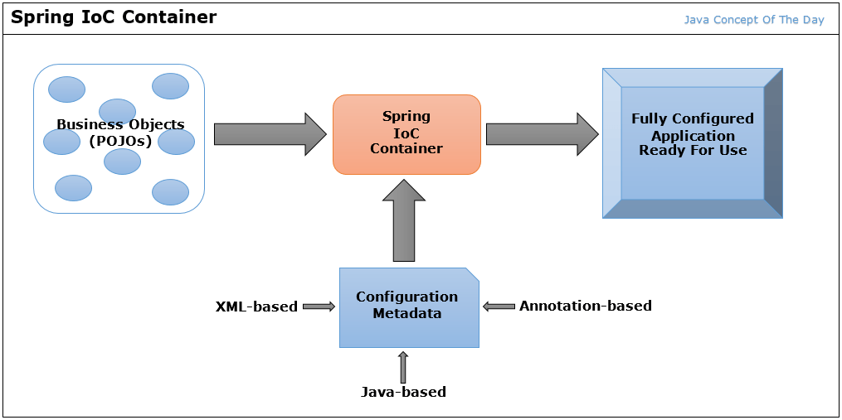

**Core Rules / Best Practices**

1. **Depend on abstractions, not implementations**
   * Inject interfaces (PaymentProcessor), not concrete classes (StripeProcessor).
2. **Declare wiring externally**
   * Use XML, Java-config (@Configuration), or component-scan + stereotypes (@Component) to define relationships.
3. **Favor constructor injection for mandatory deps**
   * Makes immutability and clear requirements easier; use setter injection for optional collaborators.
4. **Minimize container API usage**
   * Your code should use only plain Java and DI annotations; avoid calling ApplicationContext.getBean(...) except at bootstrapping.
5. **Scope appropriately**
   * Default to singleton for stateless services; use prototype, request, or session only when you need per-use or per-user instances.

**When & Where to Use Spring IoC**

* **All non-trivial Java apps** where you need: modularity, testability, or runtime flexibility
* **Microservices** built with Spring Boot—each service wires its own beans
* **Plugin or extension systems**—new modules can be picked up automatically via classpath scanning
* **Legacy modernization**—gradually introduce IoC to untangle a monolith

**Real-World Examples of IoC in Action**

1. **Payment Service Integration**
   * Define a PaymentProcessor interface
   * Provide implementations (StripeProcessor, PayPalProcessor)
   * Container injects the chosen bean based on a profile (@Profile("stripe")) without code changes
2. **Feature-Flagged Notification System**
   * NotificationService has optional EmailSender and SmsSender dependencies
   * Conditional wiring via @ConditionalOnProperty("notifications.sms.enabled")
   * Turn features on/off via external properties, no code edits
3. **Data Access Layer Swap**
   * Early phase: JdbcTemplateOrderRepository wired for relational DB
   * Later: switch to MongoOrderRepository by changing a single bean definition or starter dependency
   * Business code (OrderService) remains unaware of the change

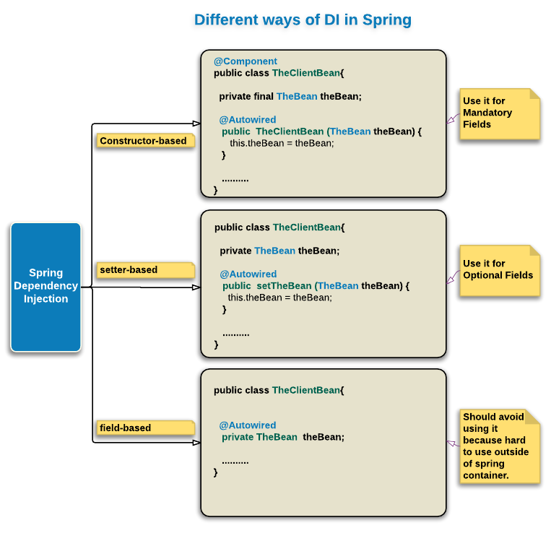

## 2. Spring Beans

**What & Why it Came**

* **Definition:** A **Spring Bean** is simply an object instantiated, assembled, and managed by the Spring IoC container. Every bean has a definition (its class, scope, lifecycle callbacks, etc.) that the container uses to control its lifecycle.
* **Origins:** Beans formalize objects in your app as first-class container citizens—allowing unified lifecycle management, AOP proxying, and externalized configuration.

**Core Rules / Bean Best Practices**

1. **Register beans via one mechanism**
   * XML <bean>, Java-config @Bean, or stereotype annotations (@Component, @Service, @Repository, @Controller)—pick one style per project.
2. **Default to singleton scope**
   * Unless you explicitly need multiple instances, keep beans as singletons for performance and consistency.
3. **Use meaningful names & qualifiers**
   * Beans with the same type should be disambiguated with @Qualifier("…") or custom bean names.
4. **Leverage lifecycle callbacks sparingly**
   * Use @PostConstruct/@PreDestroy only when you must initialize or clean up external resources (threads, sockets).
5. **Avoid container APIs in business logic**
   * Let Spring manage dependencies; don’t call BeanFactory or ApplicationContext from inside your services.

**When & Where to Use Spring Beans**

* **Any managed component** in a Spring app—service classes, repositories, controllers, schedulers, data sources.
* **Cross-cutting concerns** via AOP (ProxyFactoryBean)—logging, transactions are applied to beans.
* **Production-ready features**—health checks, metrics (spring-boot-actuator registers beans under the hood).

**Real-World Examples of Spring Beans**

1. **@Service Business Bean**

@Service

public class OrderService {

private final PaymentProcessor processor;

public OrderService(PaymentProcessor processor) {

this.processor = processor;

}

public Receipt placeOrder(Order o) { … }

}

* + Managed as a singleton, gets its PaymentProcessor injected at startup.

1. **@Repository Data-Access Bean**

@Repository

public interface UserRepository extends JpaRepository<User, Long> { }

* + Spring Data creates a proxy instance at runtime, implements CRUD methods automatically.

1. **Custom @Bean in Java-Config**

@Configuration

public class DataSourceConfig {

@Bean(destroyMethod="close")

public DataSource dataSource() {

HikariDataSource ds = new HikariDataSource();

ds.setJdbcUrl(env.get("db.url"));

return ds;

}

}

* + Defines and configures a DataSource bean; Spring calls close() on shutdown.

**Bringing It Together**

* **IoC** is the **principle**: let the container manage object lifecycles and dependencies.
* **Beans** are the **units**: the POJOs that Spring instantiates, wires, and manages under that principle.

By adhering to these rules—declaring dependencies externally, scoping and naming beans thoughtfully, and leveraging Spring’s lifecycle hooks—you unlock loose coupling, runtime flexibility, and robust resource management across your Java applications.

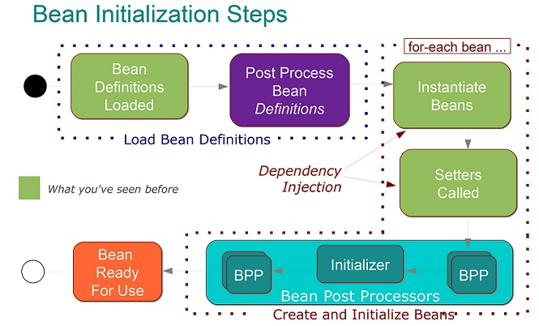

## Quiz

1. **Which of these is a Plain Old Java Object (POJO)?**  
   A. A class extending SpringBean  
   B. A class with no dependencies on framework APIs and only plain Java  
   C. A class annotated with @Component  
   D. A class implementing BeanFactory

**Answer:** B

1. **A JavaBean must have which of the following?**  
   A. A public no-arg constructor and getter/setter methods for its properties  
   B. Extend java.beans.Bean  
   C. Only static methods  
   D. Implement Serializable only  
     
   **Answer:** A
2. **What distinguishes a Spring Bean from a simple POJO?**  
   A. Spring Beans must implement InitializingBean  
   B. Spring Beans are managed by the Spring container and configured in XML or via annotations  
   C. Spring Beans cannot have constructor arguments  
   D. Spring Beans are always singletons  
     
   **Answer:** B
3. **Which module is NOT part of the core Spring Framework?**  
   A. Spring Web MVC  
   B. Spring JDBC  
   C. Spring Security  
   D. Spring Core  
     
   **Answer:** C
4. **The Spring module responsible for dependency injection and bean lifecycle is:**  
   A. Spring AOP  
   B. Spring ORM  
   C. Spring Core (Container)  
   D. Spring Batch  
     
   **Answer:** C
5. **Which of these is NOT a valid scope for a Spring Bean (classic XML/annotation)?**  
   A. singleton  
   B. prototype  
   C. request  
   D. thread  
     
   **Answer:** D
6. **What is the role of the ApplicationContext in Spring?**  
   A. Only parses XML configuration  
   B. Loads class files from the file system  
   C. Acts as the central Spring container, providing bean factory methods plus enterprise services  
   D. Manages JDBC connections only  
     
   **Answer:** C
7. **Which interface provides basic IOC (Inversion of Control) container functionality in Spring?**  
   A. ApplicationContext  
   B. BeanFactory  
   C. DispatcherServlet  
   D. ContextLoaderListener  
     
   **Answer:** B
8. **In Spring IOC, which pattern is primarily used to inject dependencies?**  
   A. Singleton  
   B. Factory  
   C. Dependency Injection (either constructor-based or setter-based)  
   D. MVC  
     
   **Answer:** C
9. **Which annotation would you use to register a class as a Spring Bean in a Java-config class?**  
   A. @Bean  
   B. @Entity  
   C. @Autowired  
   D. @Configuration  
     
   **Answer:** A
10. **What does the term “IOC” stand for in Spring?**  
    A. Input/Output Control  
    B. Inversion of Control  
    C. Instance of Container  
    D. Interface-Oriented Component  
      
    **Answer:** B
11. **Which of the following is a valid way to inject a dependency in Spring?**  
    A. Constructor injection using @Autowired on a constructor  
    B. Using new inside a bean method  
    C. Manually calling setter in main()  
    D. Extending the bean class  
      
    **Answer:** A
12. **Which container loads context definitions from a Java class annotated with @Configuration?**  
    A. XmlBeanFactory  
    B. AnnotationConfigApplicationContext  
    C. ClassPathXmlApplicationContext  
    D. ServletContextAttributeListener  
      
    **Answer:** B
13. **When a bean implements DisposableBean, Spring will call its:**  
    A. init() method after creation  
    B. destroy() method on container shutdown  
    C. start() method on startup  
    D. finalize() method on garbage collection  
      
    **Answer:** B  
    s
14. **Which of these Spring modules provides declarative transaction management?**  
    A. Spring AOP  
    B. Spring JMS  
    C. Spring Context  
    D. Spring Transactions  
      
    **Answer:** D